Drawing Clone Captain Rex
Ever wanted to draw Star Wars characters and vehicles just like the professional comic book artists? In this step-by-step series, Star Wars artists and illustrators show you how to draw some of the most beloved characters in the saga.
Anakin Skywalker's second in command during the Clone Wars, Clone Captain Rex (CC-7567) was a freethinking and aggressive soldier's-soldier. Gruff, no-nonsense and tough as nails, Rex voiced his professional opinion to even the highest-ranking Jedi. In command of the famed 501st Clone Trooper Battalion, Rex and his men were assigned to patrol the most lawless and dangerous sectors of the galaxy within the feared Outer Rim.
Star Wars illustrator Grant Gould explains with these easy-to-follow steps on how to draw Captain Rex. Steps 1-5 are to be drawn lightly with a pencil. No pen, no dark lines. Finished lines and details will come at the end.
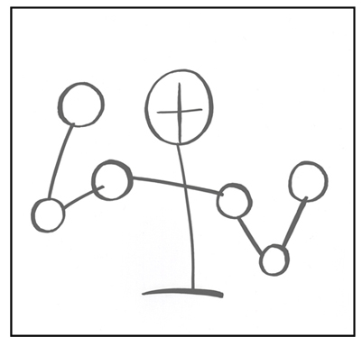
Step One:
Drawing lightly with a pencil, create a framework using basic shapes like circles and ovals. This will tell you where the shoulders are, elbows, etc.
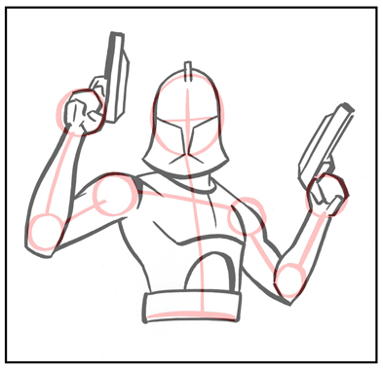
Step Two:
Now it's time to flesh out your body shapes a bit more. Again, very lightly with your pencil, draw the arms, belt, blasters, head and torso.
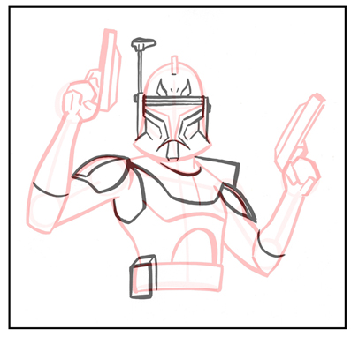
Step Three:
Once you have the basic structure of the body in place, you can start adding in details, such as the helmet lines and shoulder plates. Feel free to erase and redraw your lines until they look just right.
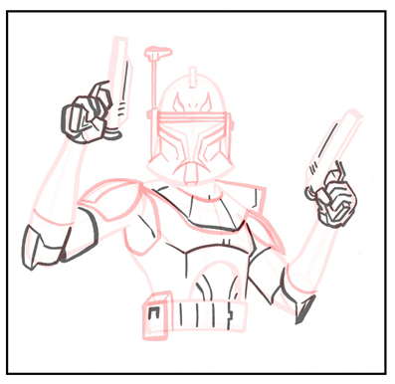
Step Four:
Continue to add details to Rex's armor, belt and blasters. Be sure to draw his fingers as well. Illustrating hands and figures can be tricky. A good way to teach yourself how to draw them more accurately is to take digital photos of your own hands in various poses. You can then use those photos as reference for when you're drawing.
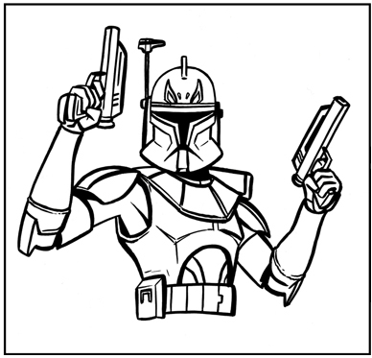
Step Five:
Go over your final lines with a pen or marker. Once your ink lines are dry, erase the pencil lines. Or use heavier pencil lines over the lighter ones. However you decide to finish your drawing is completely up to you.

